- Draw a labeled diagram of a desktop PC, clearly marking the motherboard, CPU, RAM, GPU, and both HDD and SSD storage components.
Answer :-
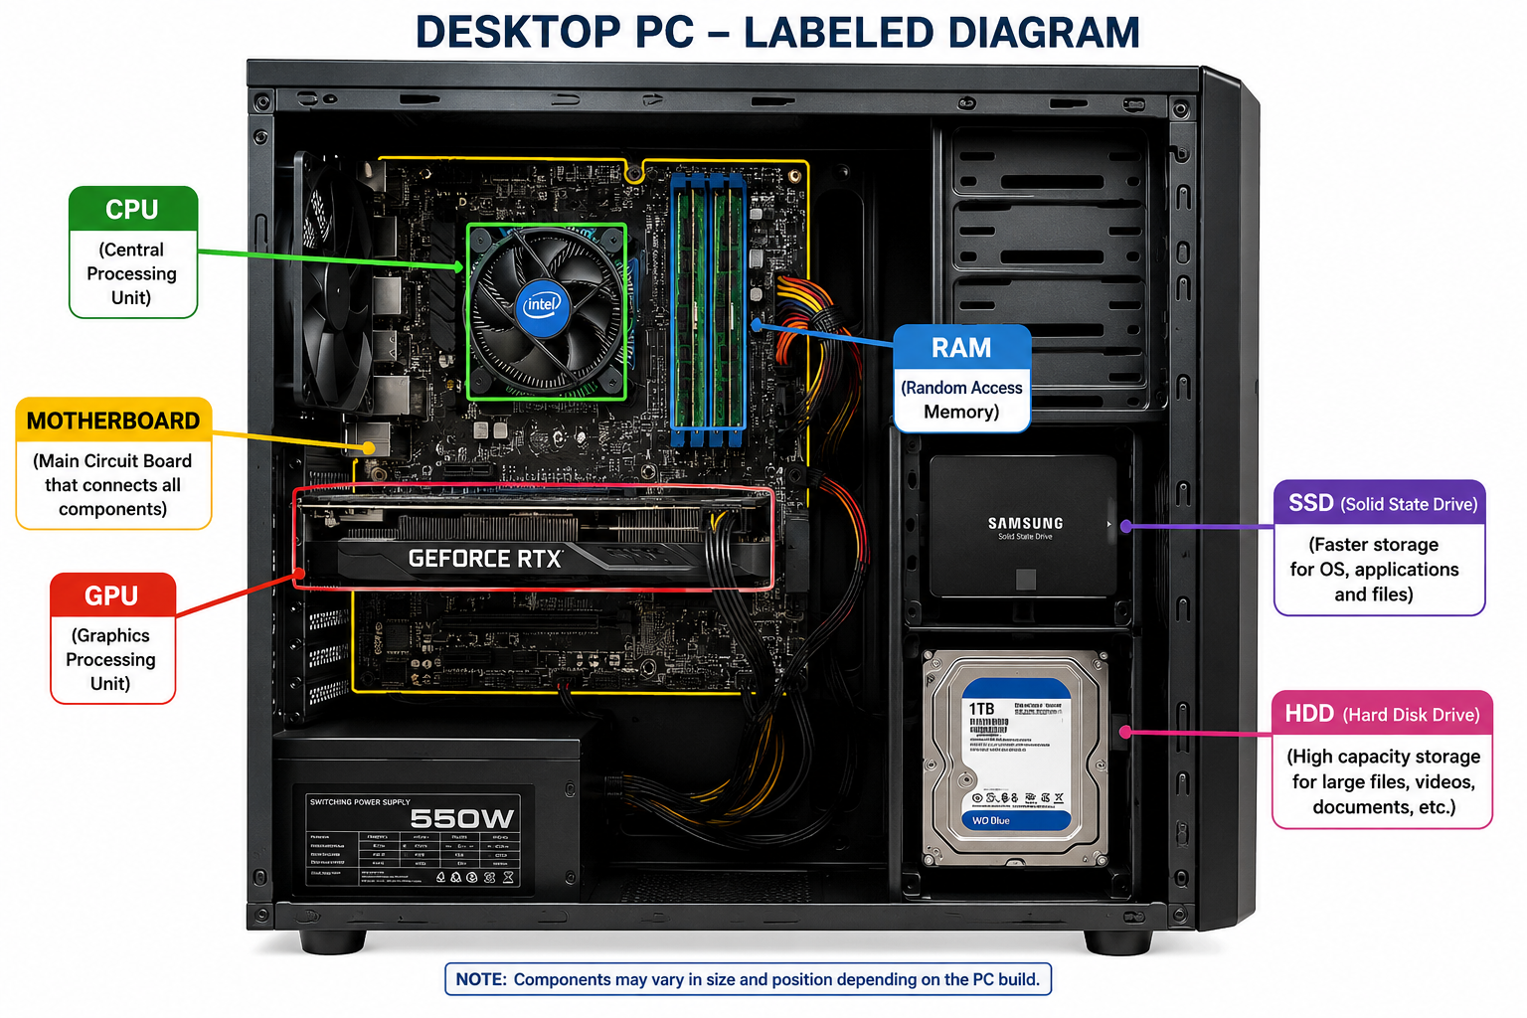

- Create a comparison table showing the main differences between HDD and SSD storage in terms of speed, durability, and typical use Cases.Think about which one is faster, which is more shock-resistant, and where you would usually find each type (laptop, gaming PC, etc.)
Answer :-
Comparison Table: HDD vs SSD Storage
Feature | HDD (Hard Disk Drive) | SSD (Solid State Drive)
Full Form | Hard Disk Drive | Solid State Drive
Storage Technology | Uses spinning magnetic disks | Uses flash memory (no moving parts)
Speed | Slower read/write speed | Much faster read/write speed
Boot Time | Takes longer to start the operating system | Boots the operating system quickly
Durability | Less durable because it has moving parts | More durable and shock-resistant because it has no moving parts
Noise | Produces some noise while operating | Completely silent during operation
Power Consumption | Consumes more power | Consumes less power
Cost | Cheaper per GB of storage | More expensive per GB of storage
Typical Use Cases | Desktop PCs, CCTV storage, backup drives, large file storage | Laptops, gaming PCs, high-performance computers, operating system drive
Best For | Users needing large storage at a lower cost | Users needing high speed and better performance

Conclusion
- HDD is best for storing large amounts of data at a lower cost.
- SSD is best for faster performance, quick boot times, and improved durability, making it ideal for modern laptops and gaming PCs.

- Write a short explanation (2-3 sentences each) describing the role of the CPU, RAM, and GPU in running a game like PUBG or Free Fire on a PC.

Answer :-

Role of CPU, RAM, and GPU in Running a Game (PUBG or Free Fire on a PC)

1. CPU (Central Processing Unit) :-
The CPU is the brain of the computer and processes all game instructions and
calculations. It manages game logic, player actions, and communication between
different hardware components to ensure smooth gameplay.

2. RAM (Random Access Memory) :-
RAM temporarily stores the game data that the CPU needs while the game is running.
More RAM allows the game to load faster, switch between tasks smoothly, and reduces
lag during gameplay.

3. GPU (Graphics Processing Unit) :-
The GPU is responsible for rendering the game's graphics, including characters,
environments, and visual effects. A powerful GPU provides higher frame rates, better
graphics quality, and smoother gaming experience in games like PUBG and Free Fire.

- Imagine you want to upgrade your PC to run the latest version of FIFA smoothly. List which hardware components you would consider upgrading and explain why for each.

Answer :-

Hardware Component | Why Upgrade It?
CPU (Processor) | A faster CPU improves game performance by processing game logic, AI, and physics more efficiently.
GPU (Graphics Card) | A Better GPU provides higher frame rates, smoother gameplay, and  improved graphics quality.
RAM | Increasing RAM (e.g., from 8 GB to 16 GB) helps the game run smoothly and reduces lag, especially when multitasking.
SSD (Solid State Drive) | Replacing an HDD with an SSD reduces game loading times and makes the system more responsive.
Power Supply Unit (PSU) | A higher-capacity PSU may be required to safely support upgraded components like a high-performance graphics card.

